**SCCI/00617/2021**

**FELIX KEMBOI**

**COMPUTER TECHNOLOGY**

1. **Pick an appropriate software engineering methodology (2 Marks)**

Incremental Development is compatible with this project as the initial versions would tend to provide the feedback of what the system lacks and therefore do appropriate amendments before the final version of the software is available for use. This would ensure the consumers of the system would be satisfied with the end product of the system.

1. **Software development models**
2. **CONTEXT MODEL (5 marks)**

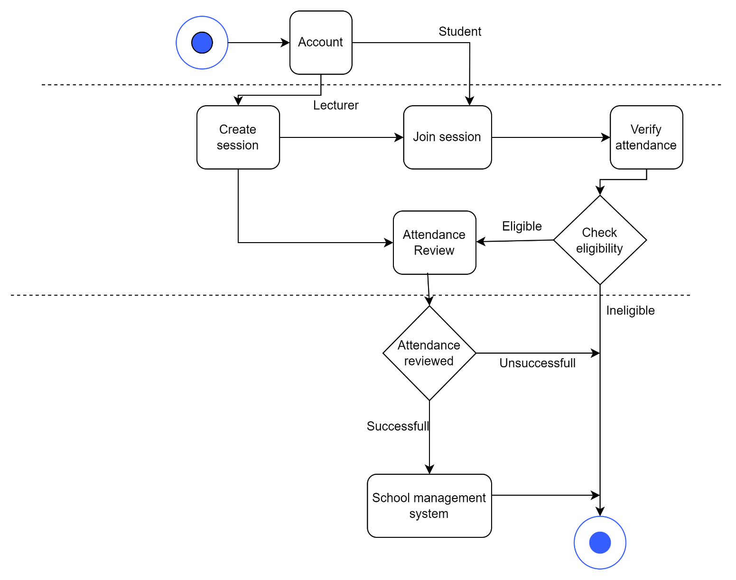

1. **Use Case Interaction Model Diagram**

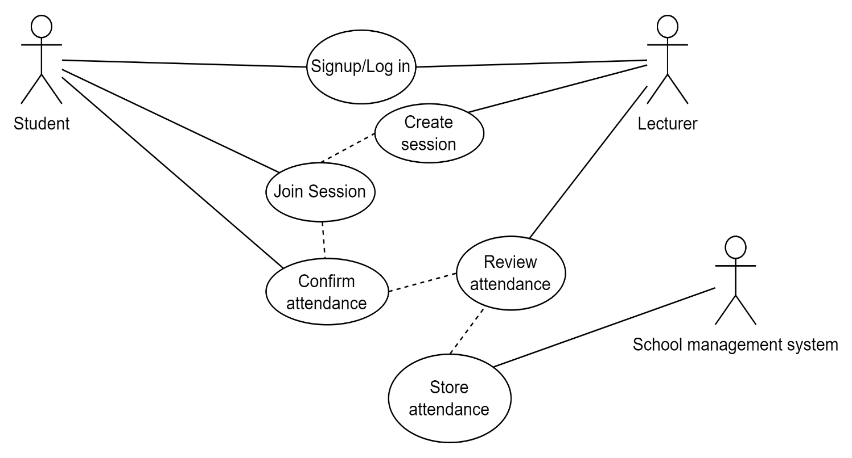

1. **STRUCTURAL MODEL DIAGRAM**

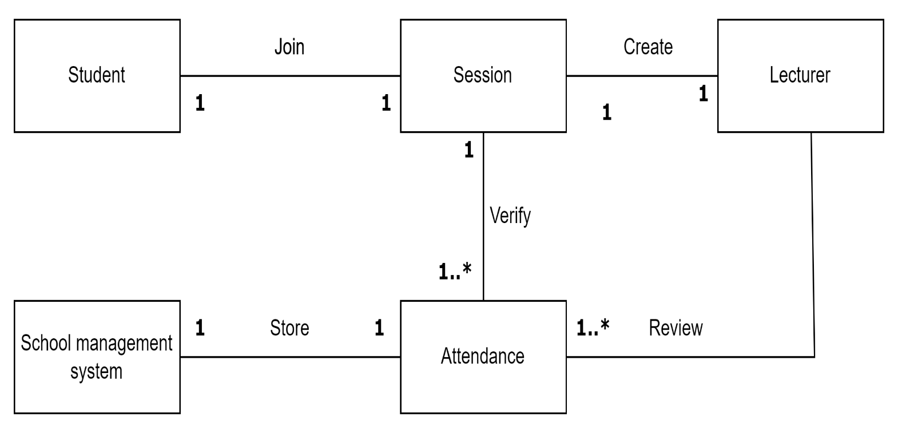

1. **Behavioral Model Diagram**

